APPLIED LINEAR ALGEBRA

DA-1

NAME : TVS PRANEETH

REG NO: 15BCE0494

Projection Reflection of vectors

Reflection:

. In mathematics, a reflection (also spelled reflexion) is a mapping from a Euclidean space to itself that is an isometry with a hyperplane as a set of fixed points; this set is called the axis (in dimension 2) or plane (in dimension 3) of reflection. The image of a figure by a reflection is its mirror image in the axis or plane of reflection. For example the mirror image of the small Latin letter p for a reflection with respect to a vertical axis would look like q. Its image by reflection in a horizontal axis would look like b. A reflection is an involution: when applied twice in succession, every point returns to its original location, and every geometrical object is restored to its original state.

The term "reflection" is sometimes used for a larger class of mappings from a Euclidean space to itself, namely the non-identity isometries that are involutions. Such isometries have a set of fixed points (the "mirror") that is an affine subspace, but is possibly smaller than a hyperplane. For instance a reflection through a point is an involutive isometry with just one fixed point; the image of the letter p under it would look like a d. This operation is also known as a central inversion, and exhibits Euclidean space as a symmetric space. In a Euclidean vector space, the reflection in the point situated at the origin is the same as vector negation. Other examples include reflections in a line in three-dimensional space. Typically, however, unqualified use of the term "reflection" means reflection in a hyperplane.

Construction

A figure that does not change upon undergoing a reflection is said to have reflectional symmetry.

In a plane (or, respectively, 3-dimensional) geometry, to find the reflection of a point drop a perpendicular from the point to the line (plane) used for reflection, and extend it the same distance on the other side. To find the reflection of a figure, reflect each point in the figure.

To reflect point P through the line AB using compass and straightedge, proceed as follows (see figure):

Step 1 (red): construct a circle with center at P and some fixed radius r to create points A′ and B′ on the line AB, which will be equidistant from P.

Step 2 (green): construct circles centered at A′ and B′ having radius r. P and Q will be the points of intersection of these two circles.

Point Q is then the reflection of point P through line AB.

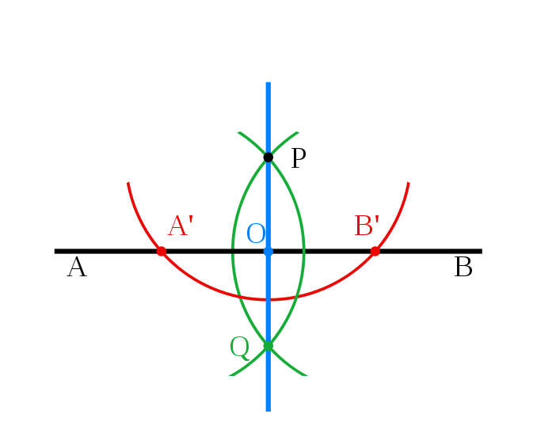

The matrix for a reflection is orthogonal with determinant −1 and eigenvalues −1, 1, 1, ..., 1. The product of two such matrices is a special orthogonal matrix that represents a rotation. Every rotation is the result of reflecting in an even number of reflections in hyperplanes through the origin, and every improper rotation is the result of reflecting in an odd number. Thus reflections generate the orthogonal group, and this result is known as the Cartan–Dieudonné theorem.

Similarly the Euclidean group, which consists of all isometries of Euclidean space, is generated by reflections in affine hyperplanes. In general, a group generated by reflections in affine hyperplanes is known as a reflection group. The finite groups generated in this way are examples of Coxeter groups.

Reflection across a line in the plane:

Reflection across a line through the origin in two dimensions can be described by the following formula:

REF1 V=2(V.L/L.L)(L-V,)

where v denotes the vector being reflected, l denotes any vector in the line being reflected in, and v·l denotes the dot product of v with l. Note the formula above can also be described as:

REF1 V=2PROV-V,

where the reflection of line l on v is equal to 2 times the projection of v on line l minus v. Reflections in a line have the eigenvalues of 1, and −1.

Given a vector a in Euclidean space Rn, the formula for the reflection in the hyperplane through the origin, orthogonal to a, is given by

REF V=V-2(V.a/a..a)a,

where v ⋅ a denotes the dot product of v with a. Note that the second term in the above equation is just twice the vector projection of v onto a. One can easily check that

Refa(v) = −v, if v is parallel to a, and

Refa(v) = v, if v is perpendicular to a.

Using the geometric product, the formula is

Ref (v)= -ava/a^2

properties

The matrix for a reflection is orthogonal with determinant −1 and eigenvalues −1, 1, 1, ..., 1. The product of two such matrices is a special orthogonal matrix that represents a rotation. Every rotation is the result of reflecting in an even number of reflections in hyperplanes through the origin, and every improper rotation is the result of reflecting in an odd number. Thus reflections generate the orthogonal group, and this result is known as the Cartan–Dieudonné theorem.

Similarly the Euclidean group, which consists of all isometries of Euclidean space, is generated by reflections in affine hyperplanes. In general, a group generated by reflections in affine hyperplanes is known as a reflection group. The finite groups generated in this way are examples of Coxeter groups.

Reflections and Projections that the projection of v into W is the midpoint of the vector v and its reflection Hv = ReflW (v); that is, Qv = 1 2 (v + Hv) or, equivalently Hv = 2Qv − v, where Q = QW denotes the projection onto W. (This is not the same as Qu in the previous section, which was projection onto the normal of W.) Recall that v = Iv, where I is the identity matrix. Since these identities hold for all v, we obtain the matrix identities: Q = 1 2 (I + H) and H = 2Q − I, So once you have computed the either the projection or reflection matrix for a subspace of R n , the other is quite easy to obtain

Reflections We have seen earlier in the course that reflections of space across (i.e. through) a plane is linear transformation. Like rotations, a reflection preserves lengths and angles, although, unlike rotations, a reflection reverses orientation (“handedness”). Once we have projection matrices it is easy to compute the matrix of a reflection. Let W denote a plane passing through the origin, and suppose we want to reflect a vector v across this plane, as in Figure 2. Let u denote a unit vector along W⊥, that is, let u be a normal to the plane W. We will think of u and v as column vectors. The projection of v along the line through u is then given by: vˆ = P roju(v) = u(u T u) −1u T v. But since we chose u to be a unit vector, u T u = u · u = 1, so that vˆ = P roju(v) = uuT v. Let Qu denote the matrix uuT , so that ˆv = Quv. What is the reflection of v across W? It is the vector ReflW (v) that lies on the other side of W from v, exactly the same distance from W as is v, and having the same projection into W as v. See Figure 2. The distance between v and its reflection is exactly twice the distance of v to W, and the difference between v and its reflection is perpendicular to W. That is, the difference between v and its reflection is exactly twice the projection of v along the unit normal u to W. This observation yields the equation: v − ReflW (v) = 2Quv, so that ReflW (v) = v − 2Quv = Iv − 2Quv = (I − 2uuT )v. The matrix HW = I − 2uuT is called the reflection matrix for the plane W, and is also sometimes called a Householder matrix

Projection:

The **vector projection** of a vector **a** on (or onto) a nonzero vector **b** (also known as the **vector component** or **vector resolution** of **a** in the direction of **b**) is the [orthogonal projection](https://en.wikipedia.org/wiki/Orthogonal_projection) of **a** onto a [straight line](https://en.wikipedia.org/wiki/Straight_line) parallel to **b**. It is a vector parallel to **b**, defined as

The vector projection of a on b is the unit vector of b by the scalar projection of a on b:

|  |  |  |
| --- | --- | --- |
| proj ba = | a · b | b |
| |b|2 |

The scalar projection of a on b is the [magnitude](http://onlinemschool.com/math/library/vector/length/) of the vector projection of a on b.

|  |  |
| --- | --- |
| |proj ba| = | a · b |
| |b| |

EXAMPLE:

Find the projection of vector a = {1; 2} on vector b = {3; 4}.

Calculate dot product of these vectors:

a · b = 1 · 3 + 2 · 4 = 3 + 8 = 11

Calculate the magnitude of vector b:

|b| = √32 + 42 = √9 + 16 = √25 = 5

Calculate vector projection:

|  |  |  |  |  |
| --- | --- | --- | --- | --- |
| proj ba = | a · b | b = | 11 | {3; 4} ={1.32; 1.76} |
| |b|2 | 25 |

Calculate scalar projection:

|  |  |  |  |  |
| --- | --- | --- | --- | --- |
| |proj ba| = | a · b | = | 11 | = 2.2 |
| |b| | 5 |

One important use of dot products is in projections. The scalar projection of **b** onto **a** is the *length* of the segment AB shown in the figure below. The vector projection of **b** onto **a** is the *vector* with this length that begins at the point A points in the same direction (or opposite direction if the scalar projection is negative) as **a**.

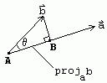

Thus, mathematically, the scalar projection of **b** onto **a** is |**b**|cos(theta) (where theta is the angle between **a** and **b**) which from (*) is given by

https://math.oregonstate.edu/home/programs/undergrad/CalculusQuestStudyGuides/vcalc/dotprod/img5.gif

This quantity is also called the component of **b** in the **a** direction (hence the notation comp). And, the vector projection is merely the unit vector **a**/|**a**| times the scalar projection of **b** onto **a**:

https://math.oregonstate.edu/home/programs/undergrad/CalculusQuestStudyGuides/vcalc/dotprod/img6.gif

Thus, the scalar projection of **b** onto **a** is the magnitude of the vector projection of **b** onto **a**.